PART 1:short answers
- DBMS is a software system that manages to store data in a centralized way and retrives the data in a structured format , it connects the central database with multiple users and it can helps users to create and update the database easily. while in the traditional file system data was managed using basic file systems on hardware devices. It resulted in duplicate entries,outdated information etc. example: in a company to record the number of employees if we use traditional file system it results in different departments in every file which is a waste of space,and the updated information should be changed in all the departments etc. while in DBMS all the data is in a database with different needed entities.
- In an ER diagram a weak entity is denoted by double rectangles and its primary key depends on the strong entity while a strong entity Is denoted by a single rectangle and has a primary key of its own. The primary key of a weak entity is formed by the primary key of the strong entity and the partial key of the weak entity. And the relationship that connects the strong entity to the weak entity Is the identifying relationship.
- Since the phone numbers of students may be multiple or single the phone number attribute must be multivalued attribute as they store the phone numbers of more than one for a given entity.
- SUPER KEY: any attribute or set of attributes that uniquely identifies all the attributes in a relationship.
CANDIDATE KEY: it is a set of attributes that uniquely identify the rows in a table or a relation.
In the example the two candidate keys are roll no. and email . and the two upper keys that are not candidate keys can be [roll no.,branch] and [email,name].
- The constraint that is violated is foreign key constraint.it makes sure that every student id in the enrollment table is the correct one that exists in the student table. The insert operation will fail since the student id inserted does not exist in the student table.
- An additional structure called junction table must be created. Its primary key consists of the primary keys of both the entities . in the entity table one cell can only hold one value but if we store them column vise in many to many relationship the cell might have to hold more than one value.

PART 2: long answers
Part A
Entity 1: customer
Key attributes: customer id,name,phone no.,address
Entity 2: restaurant
Key attributes: restaurant id,name,phone no.,address
Entity 3: menu item
Key attributes: name,item id,cost
Entity 4: order
Key attributes: amount,order id,order date

Relationships and cardinality:
- Customer-orders-order
Cardinality: 1:n
A customer may order many orders but each order belongs to only one customer.
- Restaurant -receives-order
Cardinality: 1:n
A restaurant may receive many orders but one specific order belongs to only one restaurant.
- Restaurant-provides-menu items
Cardinality: 1:n
A restaurant may have many menu items but that particular menu item belongs to only that restaurant.
- Order-contains-menu items
Cardinality: n:n
An order may have multiple menu items and menu items may be placed by multiple orders.
Part B
One multi-valued attribute may be the customers phone number or the restaurants phone number. It qualifies because the phone numbers may be more than one for the customer or the restaurant.
One composite attribute may be the address of the restaurant . which has several other attributes associated with it like house number,building name,street,city etc.
Part C
order m contains n menu items
relational schema: order item(order id,item id,quantity,unit_price,total_amount)
primary key:[order id+ item id]
foreign keys: order id and item id
additional attributes required: quantity,unit_price,total_amount.

PART 3:
Question 1:

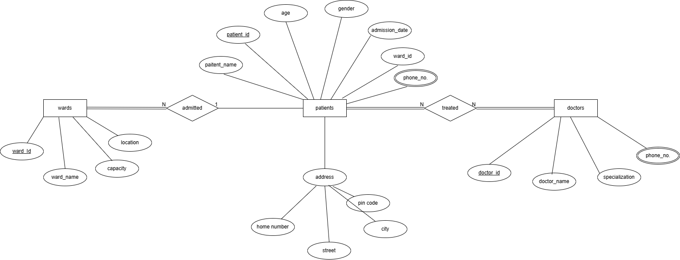

Question 2:
The doctor patient relationship is many to many because a doctor can treat many patients and a patient can have many doctors at once. This can create an association entity Treatment which entries the details of the treatment received by the patient prescribed by the doctor. The composite key of this entity consists of doctor _id , patient_id .

Ward-patient relationship: it has partial participation on both patient and the ward side. A patient may be admitted to the hospital just for doctor consultancy without being admitted to the wards and a ward room may have no patients admitted to it,so it is partial on both sides.
Patient-doctor relationship: a patient if admitted to the hospital must consult a doctor so it is not a partial participation from the patient side while a doctor may not treat any patient that day, so it is a partial participation from the doctor side.
Attributes of wards: the ward_id is unique for a given hospital so it is a key attribute, while the ward name and capacity may be similar to some other wards.
Attributes of patients: the patient_id is unique for every patient so it is the key attribute, the phone number of the patient Is multi-valued since the patient may have more than one contact number, and the address of the patient Is composite as it has sub-attributes like home no.,street,city etc.
Attributes of doctors: the doctor_id is unique for a particular doctor so it is the key attribute, and the phone number may be more than one so it is muti-valued attribute.

